Author: Daniël De Jager
+27 -- --- ----
d---@gmail.com

Assessment Writeup
6 November 2025

OVERVIEW
As tasked, I created a frequency distribution command line application using Java. The purpose is to take inputs with location data and then assign each cell tower a frequency that won’t be the same as any of those near to it to avoid interference.

GOALS
- Ensure that cell towers near to each other don’t have the same frequency.
- If possible, assign the same frequency to cell phone towers furthest from each other.
- Allow any valid input of cell ID and location data.

THE APPLICATION
The application is started in the static main function by calling the run() function that will take care of all functionality.

Reading the Input File (readFile())
First, a CSV file with the Cell ID and Easting, Northing, Longitude, and Latitude coordinates is provided. This file is parsed using readFile() using the CSVReader class. Only Easting and Northing are used and longitude and latitude are discarded as unneeded duplicate data (for the purpose of assigning frequencies). A two-dimensional Object array is created to hold the Cell ID, Easting, Northing, and Frequency, then it is returned to run().

Assigning the Frequency (assignFreq())
Next, the cellTower array is used as the parameter in assignFreq() which begins the main part of the algorithm. Here, the furthest and nearest cell towers to each tower is calculated. We calculate up to the third nearest since interfering frequencies are our primary concern. The calcDist() function is called for the purpose of calculating the distances, and the information obtained is stored accordingly.
Each cell tower receives an initial frequency from 110 to 115. Then, the furthest towers from each other are matched to receive identical frequencies. After this, we move on to the important part of the nearest cell towers not sharing frequencies. We go as deep as 3 levels, with the availability to easily add more as needed. The logic is simple: does this cell tower have the same frequency as its closest (or second closest or third closest) neighbor? If so, assign that neighbor a different frequency. There is still potential for some clustering to happen, and the algorithm can certainly be further optimised to avoid edge cases with much more time and effort.

Provide the Output
Finally, we provide a neatly formatted list with the Cell ID and assigned Frequency. This can then be put into other applications with the location data to visually verify the results. See the frequencies for the sample data as well as the Python-generated graph output below.
Cell ID | Frequency
A | 113
B | 111
C | 110
D | 112
E | 113
F | 115
G | 114
H | 110
I | 112
J | 112
K | 112
L | 111
M | 112
N | 113
O | 112
P | 110
G | 114
R | 113
S | 113

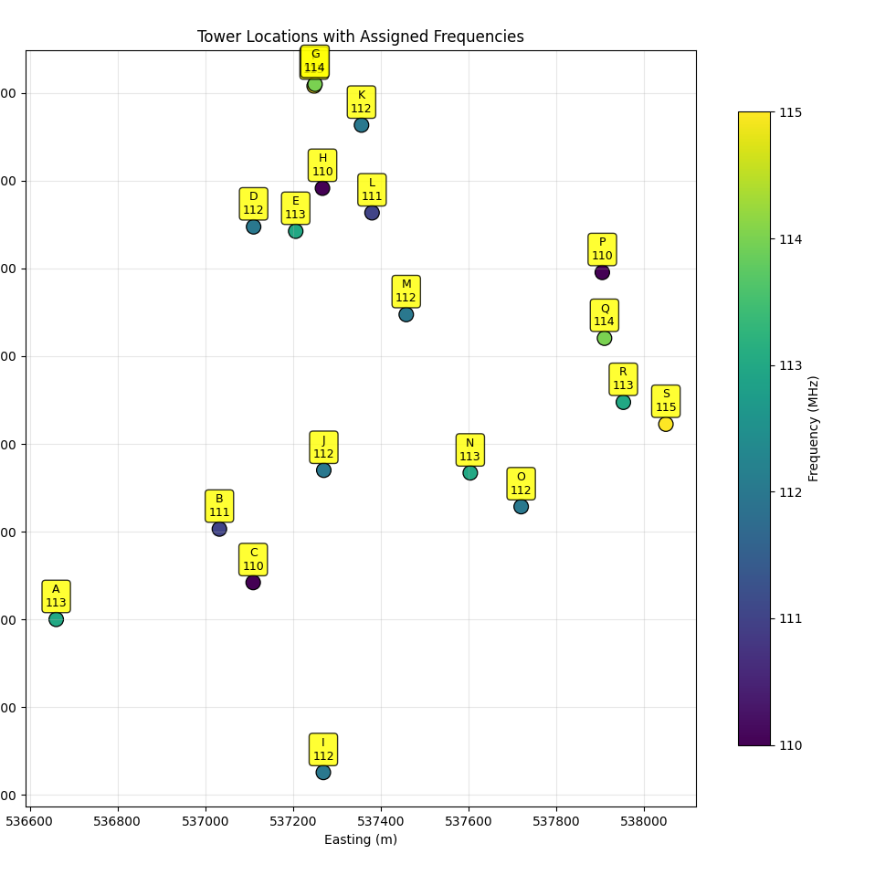

NOTES

Tools Used
- Intellij IDEA as my IDE for Java.
- Notepad++ for additional Java coding outside Java.
- Google and other resources for specific classes I was unfamiliar with.

